Medicine Prescribing System Using Machine Learning

SAIRAM V Dr.Kavitha P MCA.,M.Phil.,NET.,PhD

MCA,VELS University,Chennai. VELS University,Chennai.

Abstract: The advent machine learning (ML) technologies has revolutionized the healthcare industry, offering new avenues for improving patient care and treatment outcomes. In this study, we propose the design and implementation of an intelligent medicine recommendation system aimed at enhancing the process of prescribing medications to patients. The primary objective of this system is to assist healthcare professionals, such as doctors and pharmacists, in making informed and personalized medication recommendations based on a patient's unique medical history, conditions, allergies, and other relevant factors. By leveraging advanced AI algorithms and data analytics techniques, the system can analyze vast amounts of patient data efficiently and accurately to generate tailored medication suggestions

Keywords: web page, machine learning, detection, URL, websites

1. INTRODUCTION

The field of healthcare stands at the cusp of a transformative era, propelled by rapid advancements in artificial intelligence (AI) and machine learning (ML) technologies. One of the critical areas benefiting from this technological revolution is the development of intelligent systems that aid in medical decision-making and patient care. In this context, the focus shifts towards the design and implementation of a sophisticated Medicine Prescribing System (MPS) aimed at revolutionizing the way medications are prescribed and managed in clinical settings.

The traditional approach to medication prescription often relies on healthcare professionals' expertise and experience, supplemented by guidelines and formularies. While this human-driven approach has served well over the years, it is not without its limitations. The complexity of modern healthcare, characterized by a myriad of diseases, diverse patient populations, evolving treatment protocols, and a vast array of available medications, demands a more nuanced and data-driven approach to ensure optimal patient outcomes. The introduction of an intelligent Medicine Prescribing System represents a paradigm shift in healthcare delivery, leveraging the power of AI and ML to optimize medication management, improve patient outcomes, empower healthcare professionals, and advance the principles of precision medicine. This paper explores the design principles, implementation strategies, benefits, challenges, and future directions of such a transformative system in enhancing the quality, safety, and efficiency of healthcare services

1. LITERATURE SURVEY:

Start by identifying relevant keywords related to medicine prescribing, machine learning, and healthcare informatics. Use databases like PubMed, IEEE Xplore, and Google Scholar to search for articles. Boolean operators can help refine your search queries. Narrow down your search results based on criteria such as publication date (e.g., within the last 5 years), journal impact factor, relevance to your research objectives, and study methodology (e.g., clinical trials, retrospective studies, validation studies). Identify key journals in the fields of healthcare informatics, medical informatics, artificial intelligence in healthcare, and clinical decision support systems. Examples include the Journal of the American Medical Informatics Association (JAMIA), Artificial Intelligence in Medicine and BMC Medical Informatics and Decision Making. Look for review articles or systematic reviews that provide comprehensive summaries

of research in medicine prescribing systems using machine learning. These articles can help you identify seminal papers, key trends, and research gaps in the field. Review original research articles that describe novel machine learning algorithms, predictive models, or clinical decision support systems for medicine prescribing. Pay attention to study design, data sources, model performance metrics, and clinical outcomes Focus on articles that report results from validation studies or clinical trials of machine learning-based medicine prescribing systems. Assess the study methodologies, sample sizes, patient

Consolidating and integrating diverse sources of patient data, including electronic health records (EHRs), diagnostic reports, genetic information, and historical medication data, into a cohesive and standardized format for analysis poses a significant technical challenge. Ensuring data accuracy, completeness, and interoperability across different systems and platforms is crucial for generating reliable medication recommendations. Developing and fine-tuning AI and ML algorithms for medication recommendation requires expertise in data science, statistics, and clinical domain knowledge. Designing algorithms that can account for the complexity of patient profiles, including multiple comorbidities, drug interactions, allergies, and treatment histories, while ensuring accuracy, transparency, and interpretability, is a non-trivial task.

.

III. METHODOLOGY SECTION

The Medicine Prescribing System (MPS) can be divided into several modules, each responsible for specific functionalities and components within the system. These modules work together seamlessly to facilitate medication management, decision support, data analysis, user interactions, and system administration. Here are the main modules of the Medicine Prescribing System along with their descriptions.The backbone of the Medicine Recommendation System, providing a comprehensive and integrated platform for medication management, decision support, patient engagement, healthcare provider collaboration, data analytics, and system administration. Each module plays a vital role in enhancing medication safety, optimizing treatment outcomes, improving patient care quality, and advancing the principles of personalized medicine within healthcare settings..

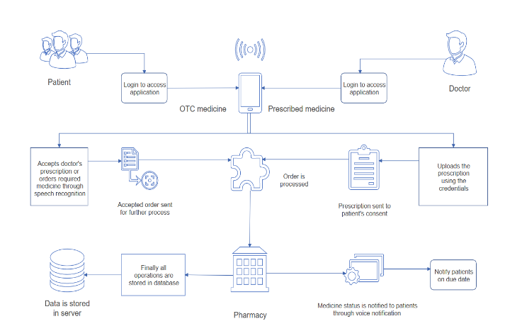

System architecture.

System Design for the Medicine Prescribing System (MPS) involves architecting a robust, scalable, and efficient platform that integrates ML algorithms, data analytics, decision support tools, user interfaces, and security measures.

IV. EXPERIMENTAL TESTING

System testing is the state of implementation, which is aimed at ensuring that the system works accurately and efficiently as expect before live operation, commences. It certifies that the whole set of programs hang together System resting requires a test plan that consists of several key activities and steps for run program, string, and system and user acceptance testing. The implementation of newly design package is important in adopting a successful new system. Testing phase is the development phase that validates the code against the functional specifications. Testing is a vital to the achievement of the system goals. The objective of testing is to discover errors. To fulfil this objective, a series of test step such as the unit test, integration test, validation and system test where planned and executed.



Home page

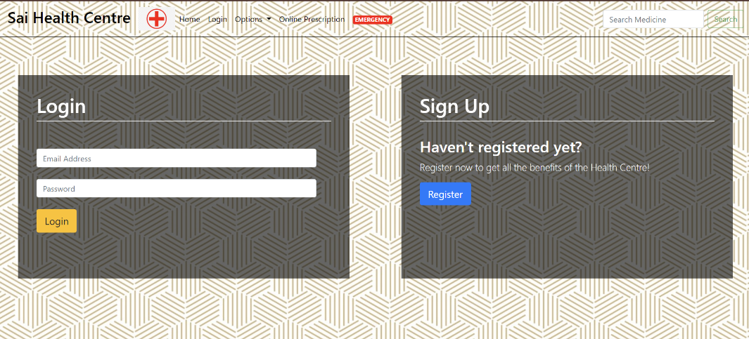

Login page

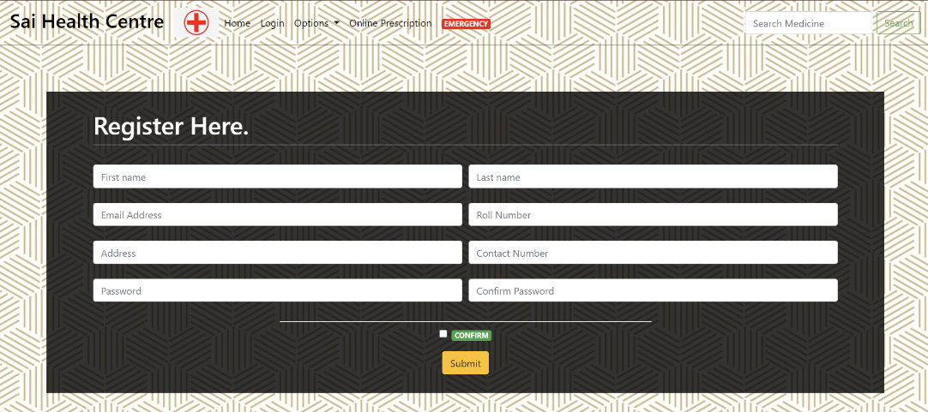

Register page

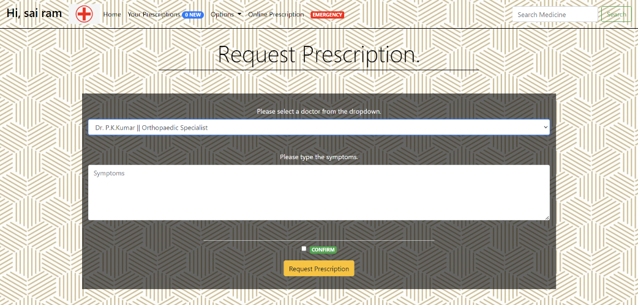

Prescription page

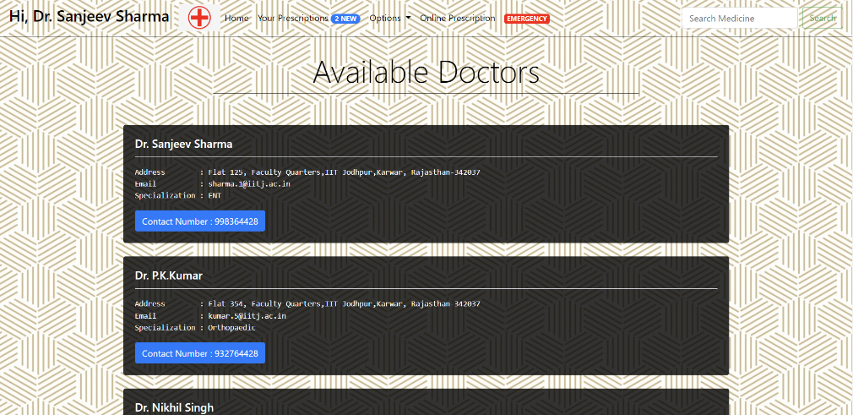

Doctors page

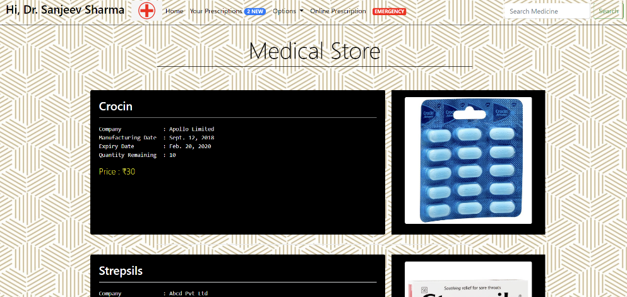

Medical store page

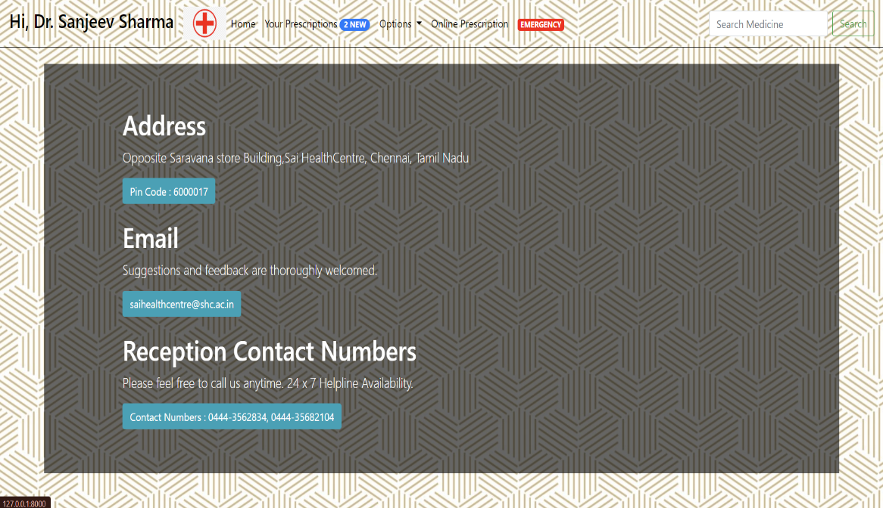

Conduct page

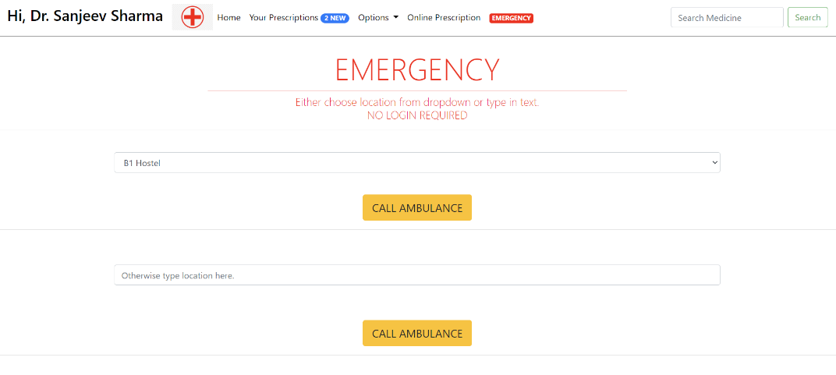

Emergency page

V. CONCLUSION

,The Medicine Prescribing System (MPS) represents a transformative solution that leverages advanced technologies, data analytics, and decision support capabilities to revolutionize medication management, enhance patient care, and empower healthcare professionals. Through the comprehensive design and implementation of the MPS, several key benefits and outcomes emerge, shaping the future of healthcare delivery and personalized medicine. The Medicine Prescribing System represents a paradigm shift in healthcare delivery, combining technological innovation with patient-centric care, evidence-based medicine, and clinical expertise. By harnessing the power of data analytics, AI-driven algorithms, interoperability, and user-centered design principles, the MPS empowers healthcare stakeholders to make informed decisions, optimize resource utilization, improve

REFERENCES

1. Albon, C. (2019). Machine Learning with Python Cookbook: Practical Solutions from Preprocessing to Deep Learning. O'Reilly Media.
2. Broucke, S. V. D., & Pickaers, M. (2020). Django for Beginners: Build Websites with Python and Django. CreateSpace Independent Publishing Platform.
3. Raschka, S., & Mirjalili, V. (2019). Python Machine Learning: Machine Learning and Deep Learning with Python, scikit-learn, and TensorFlow 2. Packt Publishing.
4. Pedroni, M. (2020). Django for APIs: Build web APIs with Python and Django. Independently Published.
5. Brownlee, J. (2018). Deep Learning for Natural Language Processing: Develop Deep Learning Models for Natural Language in Python. Machine Learning Mastery.